**Air quality monitoring system**

Phase 4

#### Abstract

1. In this phase, an IoT-based air quality monitoring platform, consisting of an air quality-sensing device called “Smart-Air” and a web server, is demonstrated.
2. This platform relies on an IoT and a cloud computing technology to monitor air quality in anywhere and anytime.
3. Smart-Air has been developed based on the IoT technology to efficiently monitor the air quality and transmit the data to a web server via LTE in real time.
4. The device is composed of a microcontroller, pollutant detection sensors, and LTE modem. In the research, the device was designed to measure a concentration of aerosol, VOC, CO, CO2, and temperature-humidity to monitor the air quality.
5. An application was developed to help in monitoring the air quality. Thus, approved personnel can monitor the air quality at any time and from anywhere, via either the web server or the application. The web server stores all data in the cloud to provide resources for further analysis of air quality.

IoT Business Solution

* While air is definitely essential to sustain life, its influence on industries is far greater. The quality of air determines the performance of workers which further influences the productivity and efficiency of the entire plant.
* Air also affects the operational costs of a company. Corrosive particles and gases present in the atmosphere can act as a catalyst for rusting and decomposition of the metal body of various industrial equipment, resulting in more repair and maintenance expenses. Furthermore, the presence of air or increased concentration of a particular gas in the air can affect the manufacturing processes, resulting in reduced quality of manufactured goods.
* Quality of air hence plays a major role in determining the overall performance of an industry. Especially in industries like mining, oil and gas, chemical, etc.; which deals with harmful gases or are subjected to aerosols; the air quality monitoring systems are a must.

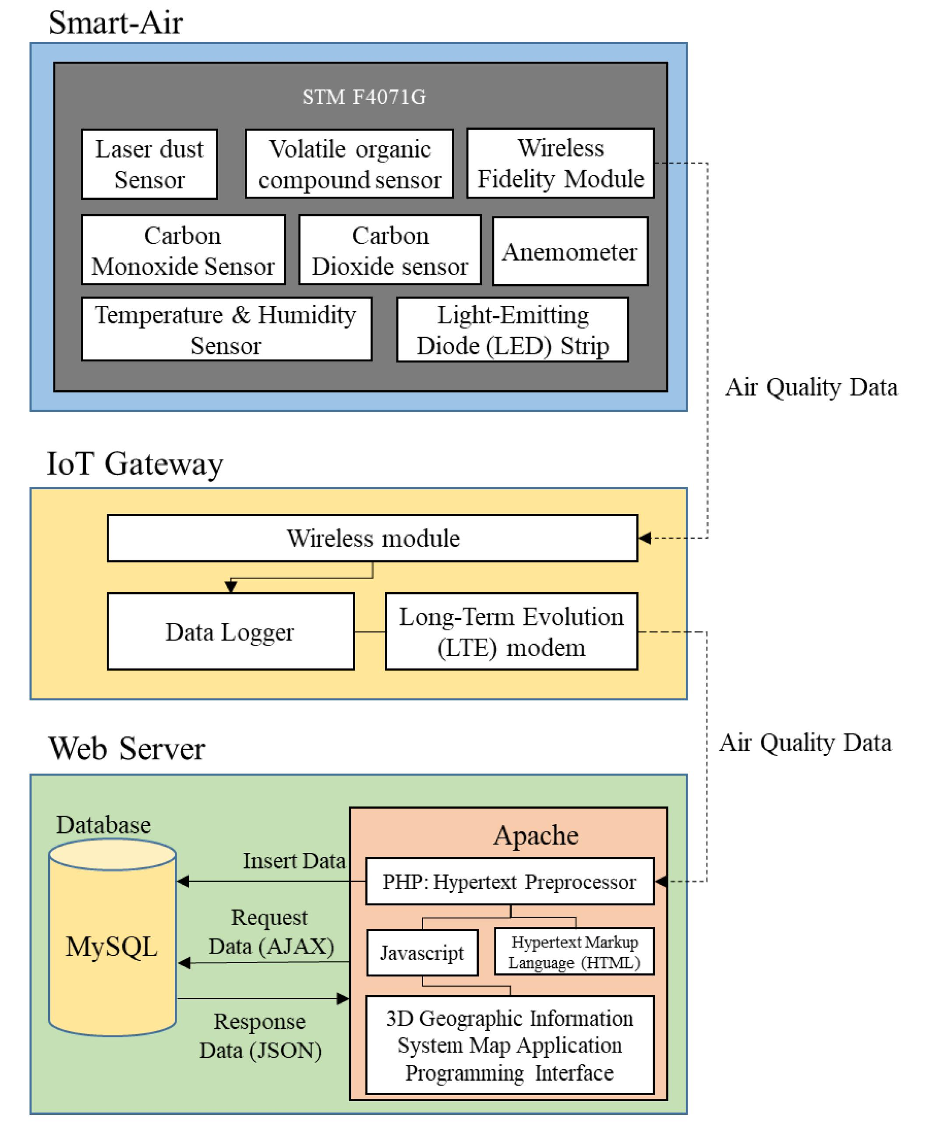

## **Using IoT as an Air Quality Monitor:**

IoT as an inter connective device acts as a perfect medium to determine the quality of air in a particular facility. High-end devices like sensors and meters embedded in strategic places can be used to ascertain the air quality index (AQI) or identify the presence of a particular harmful gas.

Powered with features such as real-time monitoring, multi-channel alerts, and advanced analytics; IoT systems are the best tools to monitor air quality. The data is transmitted to a centralized platform without any latency that enables the monitoring of AQI of a location from anyplace.

Html code for air pollution monitoring system

<!DOCTYPE html>

<html>

<head>

<title>Air Quality Monitoring System</title>

</head>

<body>

<h1>Air Quality Monitoring System</h1>

<form>

<label for="pm25">PM2.5 (µg/m³):</label>

<input type="number" id="pm25" name="pm25" min="0" step="1" required><br><br>

<label for="temperature">Temperature (°C):</label>

<input type="number" id="temperature" name="temperature" step="0.01" required><br><br>

<label for="humidity">Humidity (%):</label>

<input type="number" id="humidity" name="humidity" min="0" max="100" step="1" required><br><br>

<input type="submit" value="Submit">

</form>

<h2>Current Air Quality Data</h2>

<p>PM2.5: <span id="currentPM25">-</span> µg/m³</p>

<p>Temperature: <span id="currentTemp">-</span> °C</p>

<p>Humidity: <span id="currentHumidity">-</span> %</p>

<script>

document.querySelector('form').addEventListener('submit', function(e) {

e.preventDefault();

var pm25 = document.getElementById('pm25').value;

var temperature = document.getElementById('temperature').value;

var humidity = document.getElementById('humidity').value;

document.getElementById('currentPM25').textContent = pm25 + " ";

document.getElementById('currentTemp').textContent = temperature + " ";

document.getElementById('currentHumidity').textContent = humidity + " ";

});

</script>

</body>

</html>

Output:

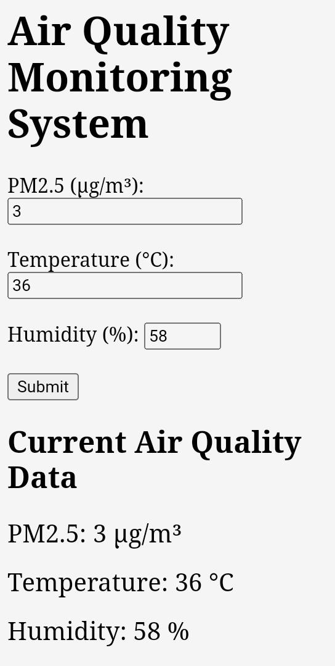

ADVANTAGES

* Sensors are easily available.
* Detecting a wide range of gases, including NH3, NOx, alcohol, benzene, smoke and CO2,Co etc
* Simple, compact & Easy to handle.
* Sensors have long life time & less cost.
* Simple Drive circuit.
* System is Real time.
* Operating voltage: 5 volt,-20°C to +50°C
* Quality of air can be checked indoor as well as outdoor.
* Visual output.
* Continous update of change in percentage of quality.

LIMITATIONS

* Only 3 sensors are used.
* Humidity should be less than 95%.
* Accurate measure of contaminating gases cannot be detected in ppm.

APPLICATIONS

* Roadside pollution Monitoring.
* Industrial Perimeter Monitoring.
* Site selection for reference monitoring stations.
* Indoor Air Quality Monitoring.
* To make this data available to the common man.

FUTURE SCOPE

In future the project can be upgraded in more ways than one.

Interface more number of sensors to know detail content of all gases present in air.

→ Design Webpage and upload data on webpage with date and time.

Interface SD Card to store data.

Interface GPS module to monitor the pollution at exact location and upload on the webpage for the netizens.